Integrated Service Order Management
SAP Service Cloud Version 2 | SAP S/4HANA Utilities | SAP Field Service Management | SAP Service and Asset Manager

Solution Design Document
Version 0.1 - July 9, 2026

By,
Jamparaju Nammi,
SAP ISU Solution Advisor

Attribute | Value
Document Title | Integrated Service Order Management - Solution Design
Scope | Service order creation with real-time appointment booking; Move-In / Move-Out / Transfer service order determination
Status | Draft v0.1
Prepared | July 9, 2026

Document Control
Version | Date | Author | Description of Change
0.1 | 2026-07-09 | Solution Architecture | Initial draft: end-to-end architecture

Terminology
Term | Definition
SCV2 | SAP Service Cloud Version 2
S/4HU | SAP S/4HANA Utilities (IS-U): system of record for utilities master and transactional data
FSM | SAP Field Service Management: scheduling, dispatching, Booking API
SSAM | SAP Service and Asset Manager: mobile work execution for internal crews (SAP Mobile Services)
CPI | SAP Cloud Integration (part of SAP Integration Suite on BTP)
AMI / RSS | Advanced Metering Infrastructure / Remote Service Switch (remote connect-disconnect command)
BRF+ | Business Rule Framework plus: decision-table rules engine embedded in S/4HANA
Opt-In / Opt-Out | Customer participation in the AMI (smart meter) program; opt-out customers keep a mechanical meter
SoR | System of Record

Table of Contents
Document Control 2
Table of Contents 3
Purpose and Scope 4
Solution Architecture Overview 4
System Responsibilities and System of Record 5
Scenario 1 - Service Order Creation with Real-Time Appointment Booking 6
Process Flow 6
APIs and Integration Patterns 7
Exception Handling and Consistency 7
Scenario 2 - Move-In / Move-Out / Transfer with Automatic Service Order Determination 8
Process Flow 8
Proposed Order Type Mapping (business view) 9
BRF+ Decision Service Design (derived from FS 1087 v0.6) 10
Functions, Signatures and Result Structure 10
Condition Derivations (BRF+ expressions and procedure calls) 10
Decision Table DT_MOVE_IN (online - move-in and transfer-in) 11
Decision Table DT_MOVE_OUT (online - move-out and transfer-out) 11
Decision Table DT_BATCH_MOVE_OUT (daily batch - RSS disconnections) 12
Decision Table DT_BATCH_MOVE_IN (daily batch - RSS reconnections) 12
Service Order Codes and Creation Parameters 12
Modernization Notes (C4C-era hook points to re-validate for SCV2) 13
Master Data and Transactional Data Dependencies 14
Assumptions and Open Questions 14
Assumptions 14
Open Questions for the Client 14
Implementation Roadmap 15
Key Design Considerations for SAP Utilities 15
Appendix A - References and Traceability 16

Purpose and Scope
This Solution Design Document specifies the end-to-end solution design for an integrated Service Order Management capability across SAP Service Cloud Version 2 (SCV2), SAP S/4HANA Utilities, SAP Field Service Management (FSM) and SAP Service and Asset Manager (SSAM). It covers two business scenarios:
- Scenario 1 - Service Order Creation from SCV2: a CSR creates a service order in SCV2, retrieves available appointment slots in real time from FSM, selects a slot and confirms the order, which is created in S/4HANA Utilities and scheduled in FSM.

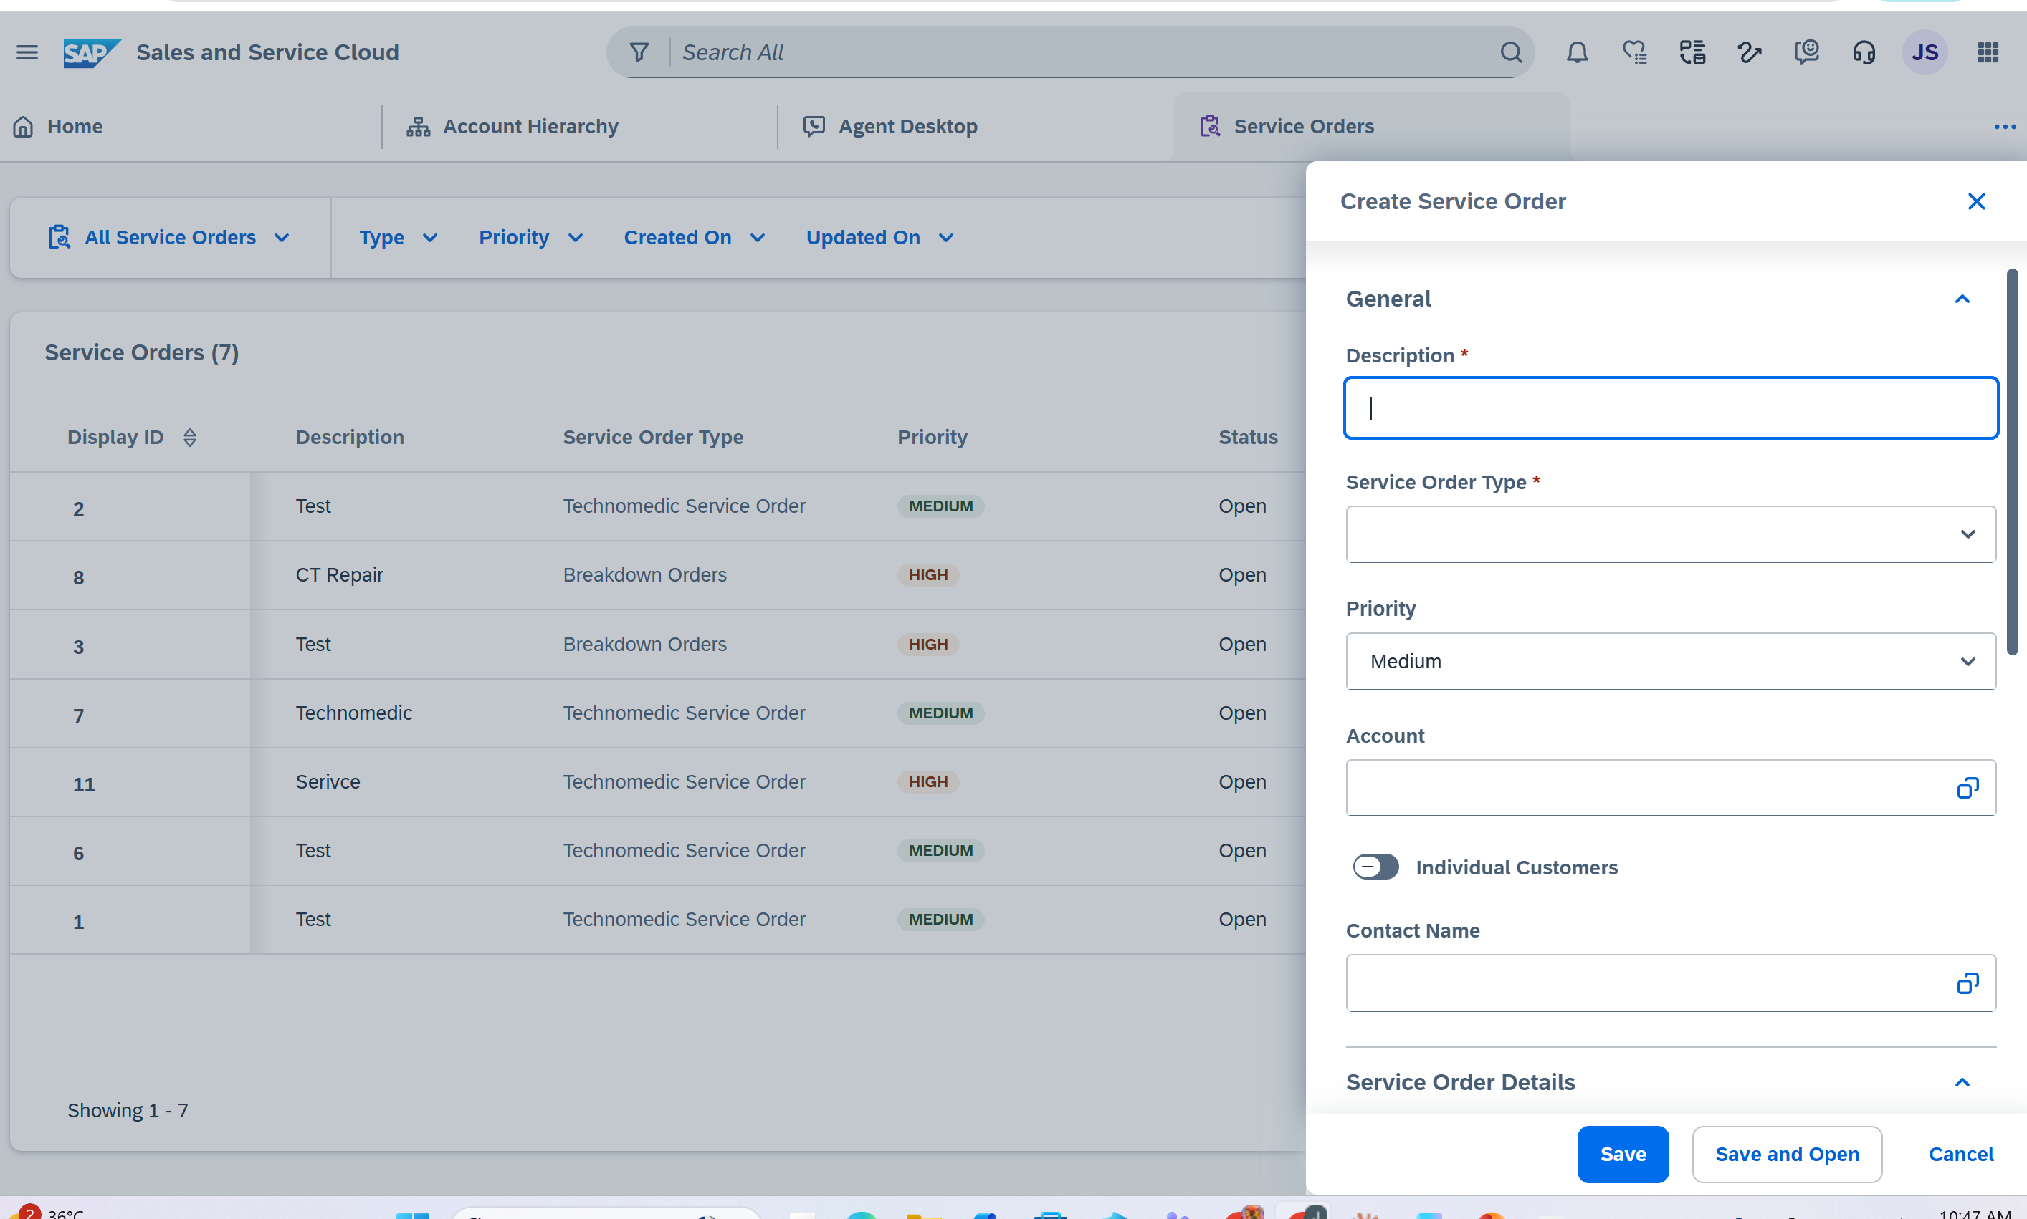

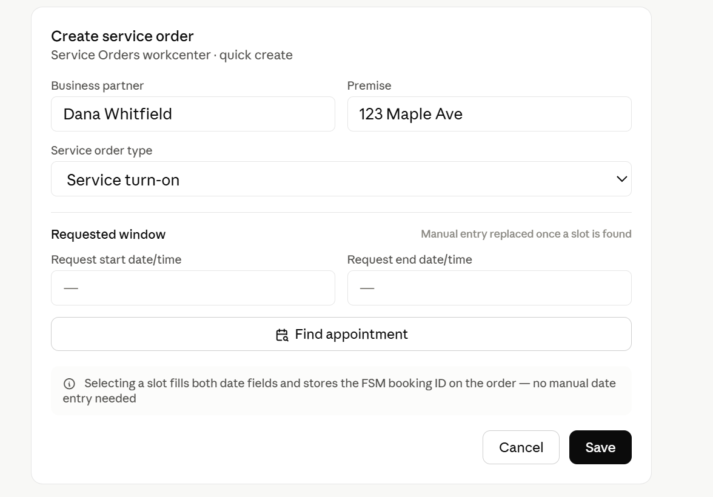

- Scenario 2 - Move-In / Move-Out / Transfer: on processing a move-in, move-out or transfer, the system automatically determines whether a field service order or a remote (AMI/RSS) command is required, and proposes the appropriate order type (Meter Exchange, Meter Read, Service Turn-On, Service Turn-Off, Meter Removal).

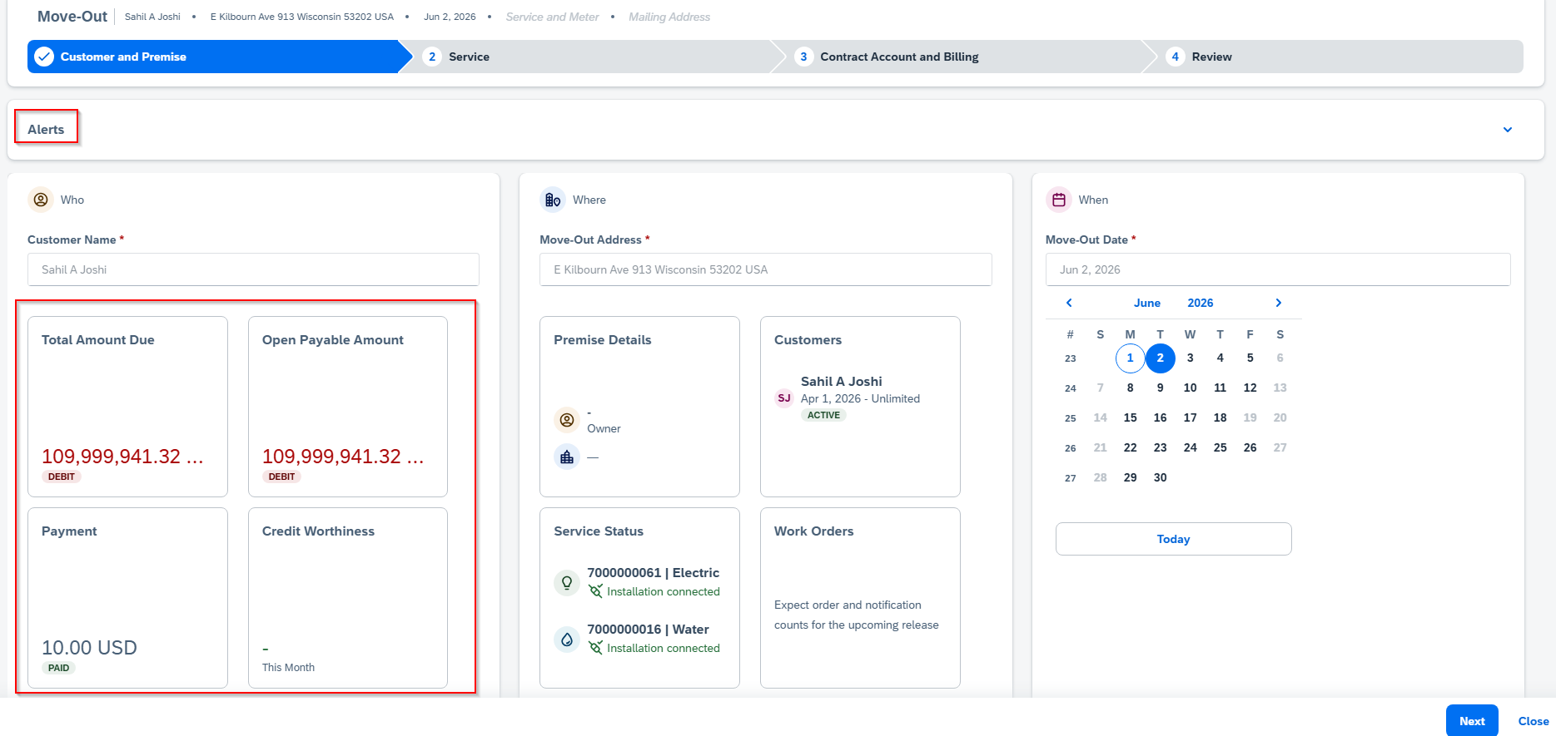

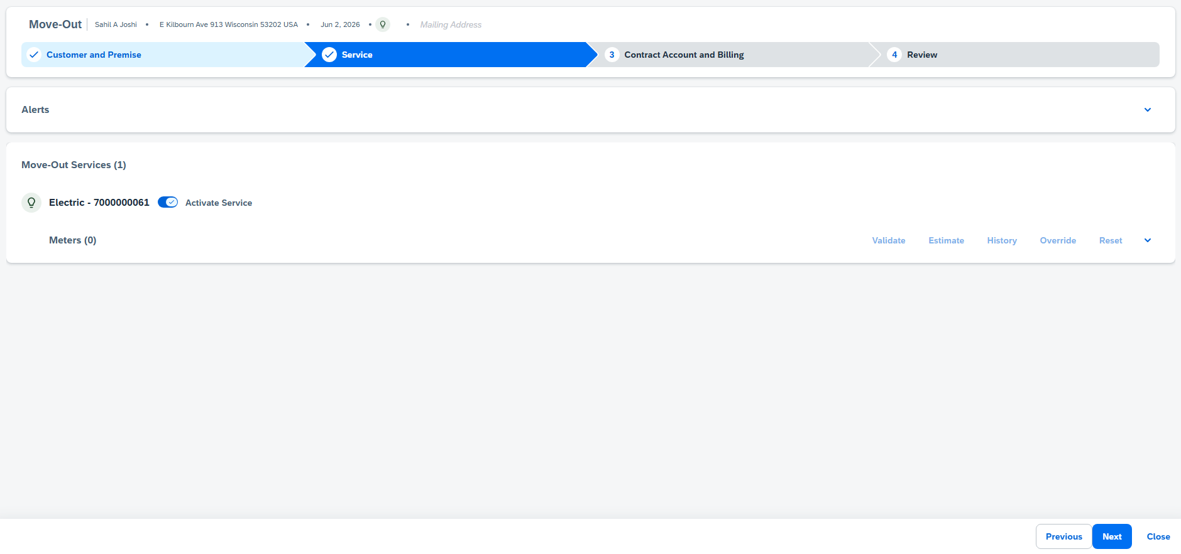

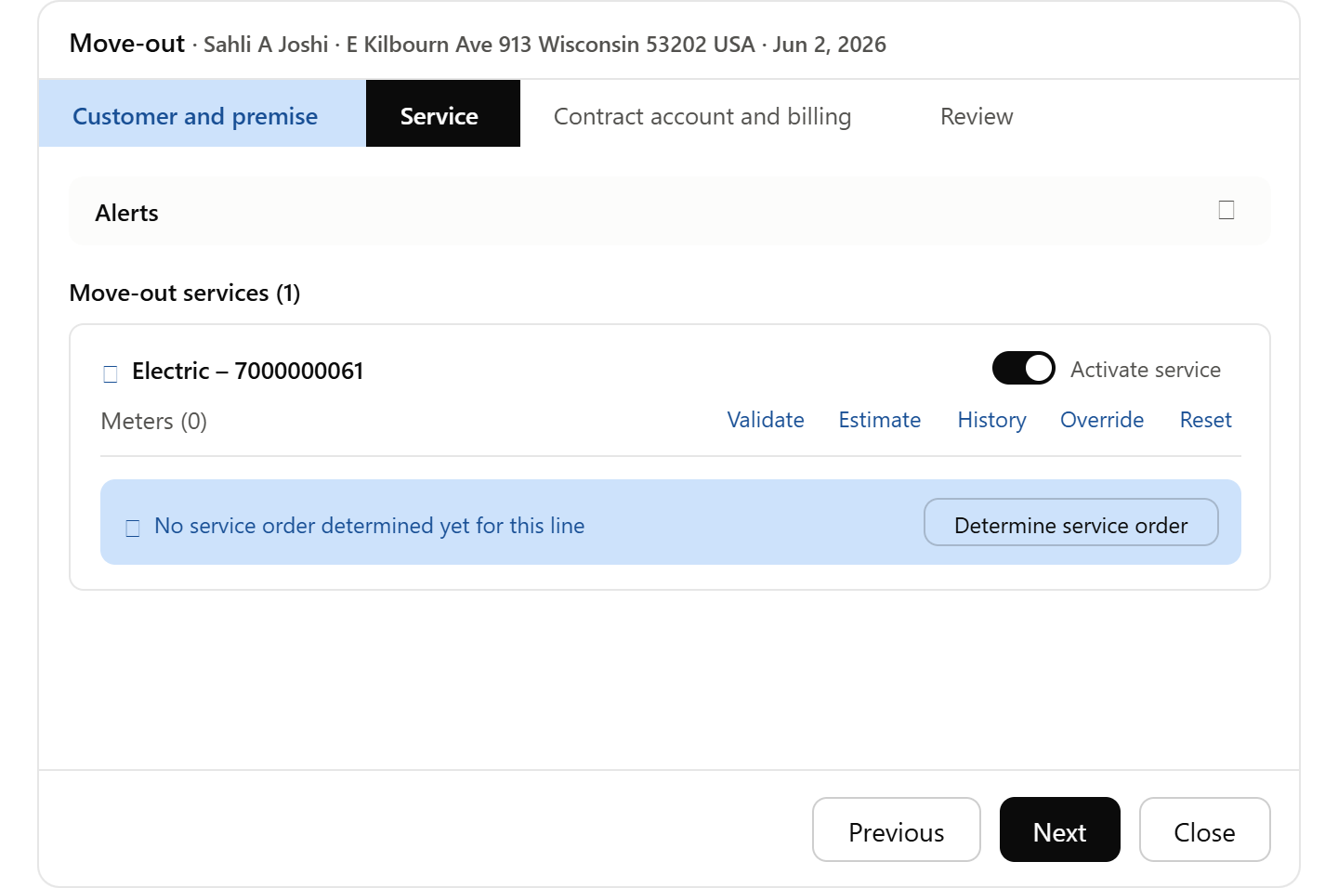

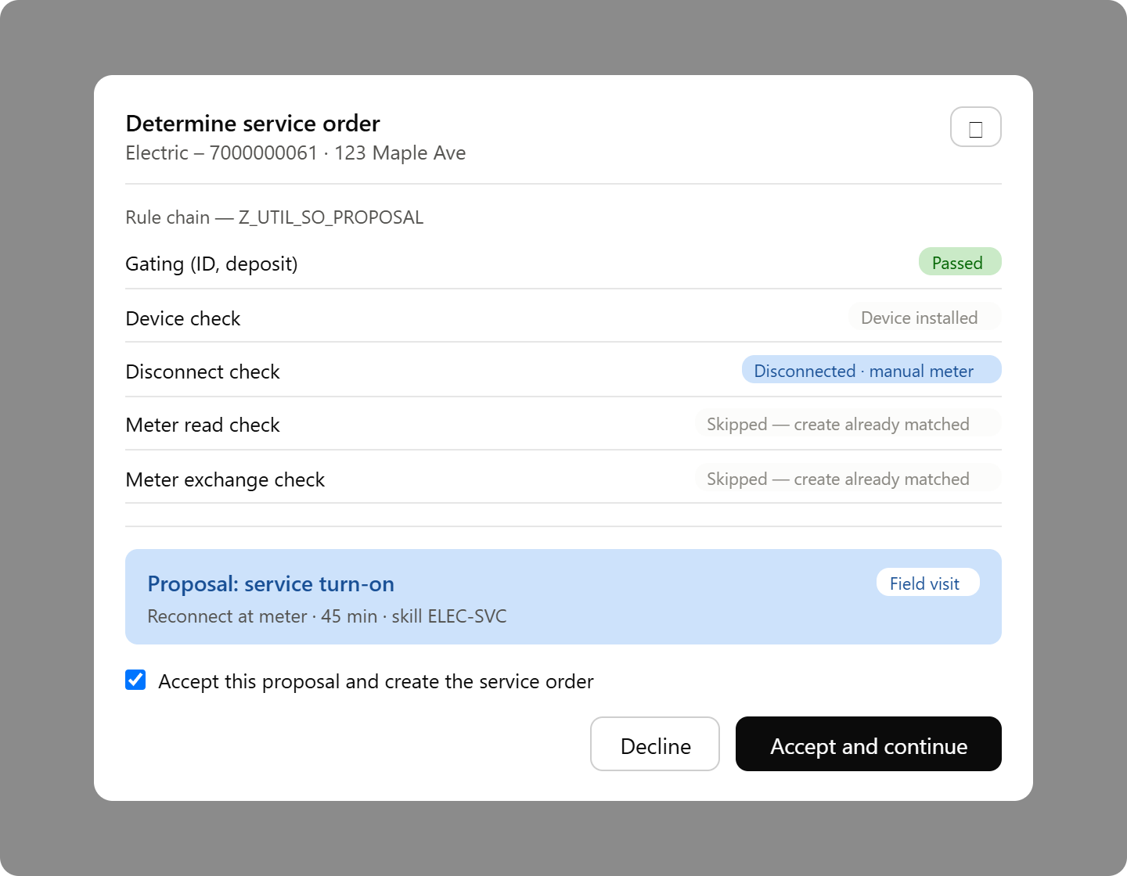

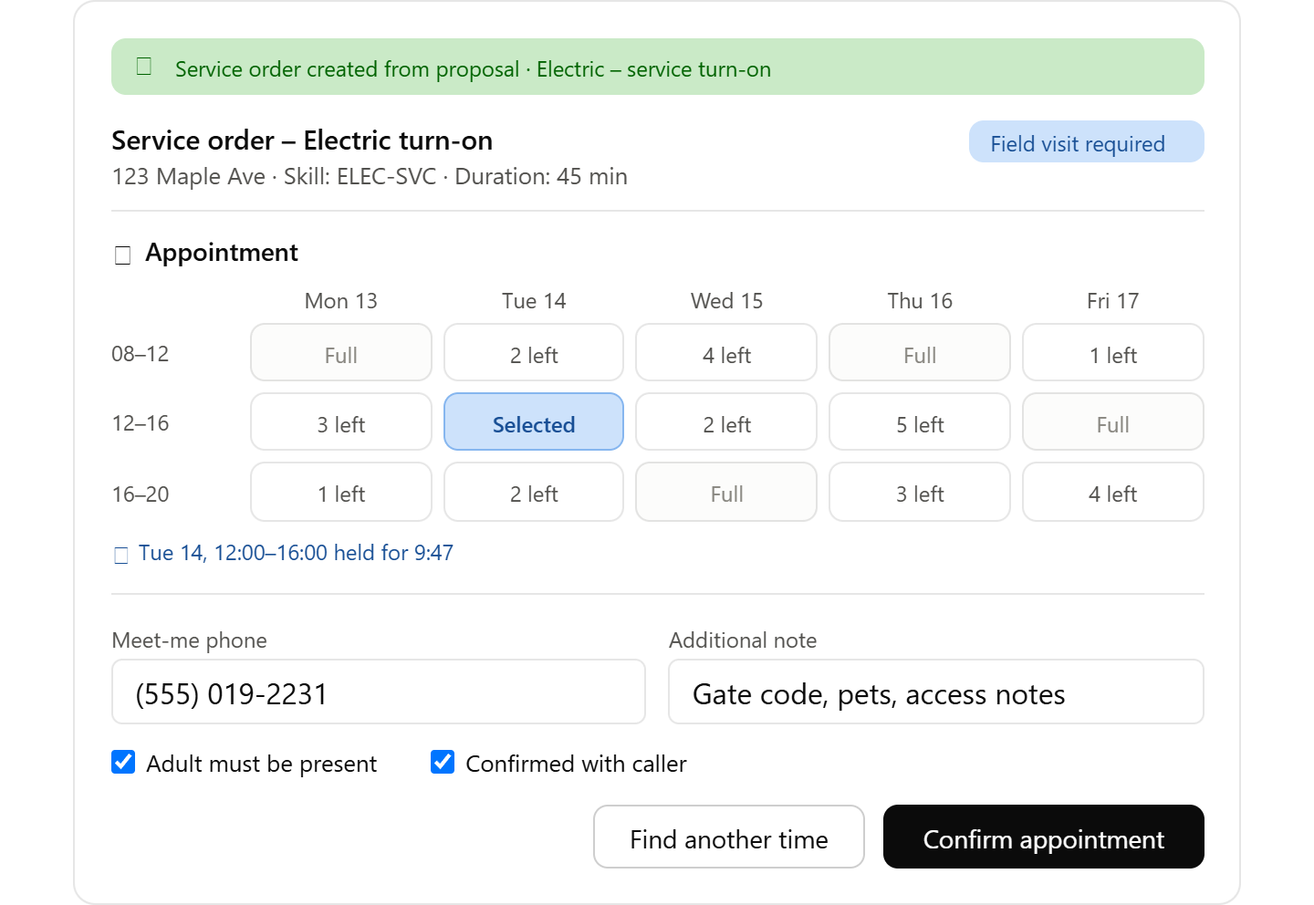

The service order determination rules in Section 6 are derived from functional specification 1087 E-CIM-CS-02 'Create Work Order During Move-In/Move-Out/Transfer' v0.6 (SCE CSRP program). That specification was written for the SAP Cloud for Customer (C4C) generation of the CRM front end; this design carries the business rules forward unchanged and re-platforms the integration layer onto SCV2 and SAP Integration Suite. C4C-era technical hook points are flagged in Section 6.9 for re-validation.

Solution Architecture Overview
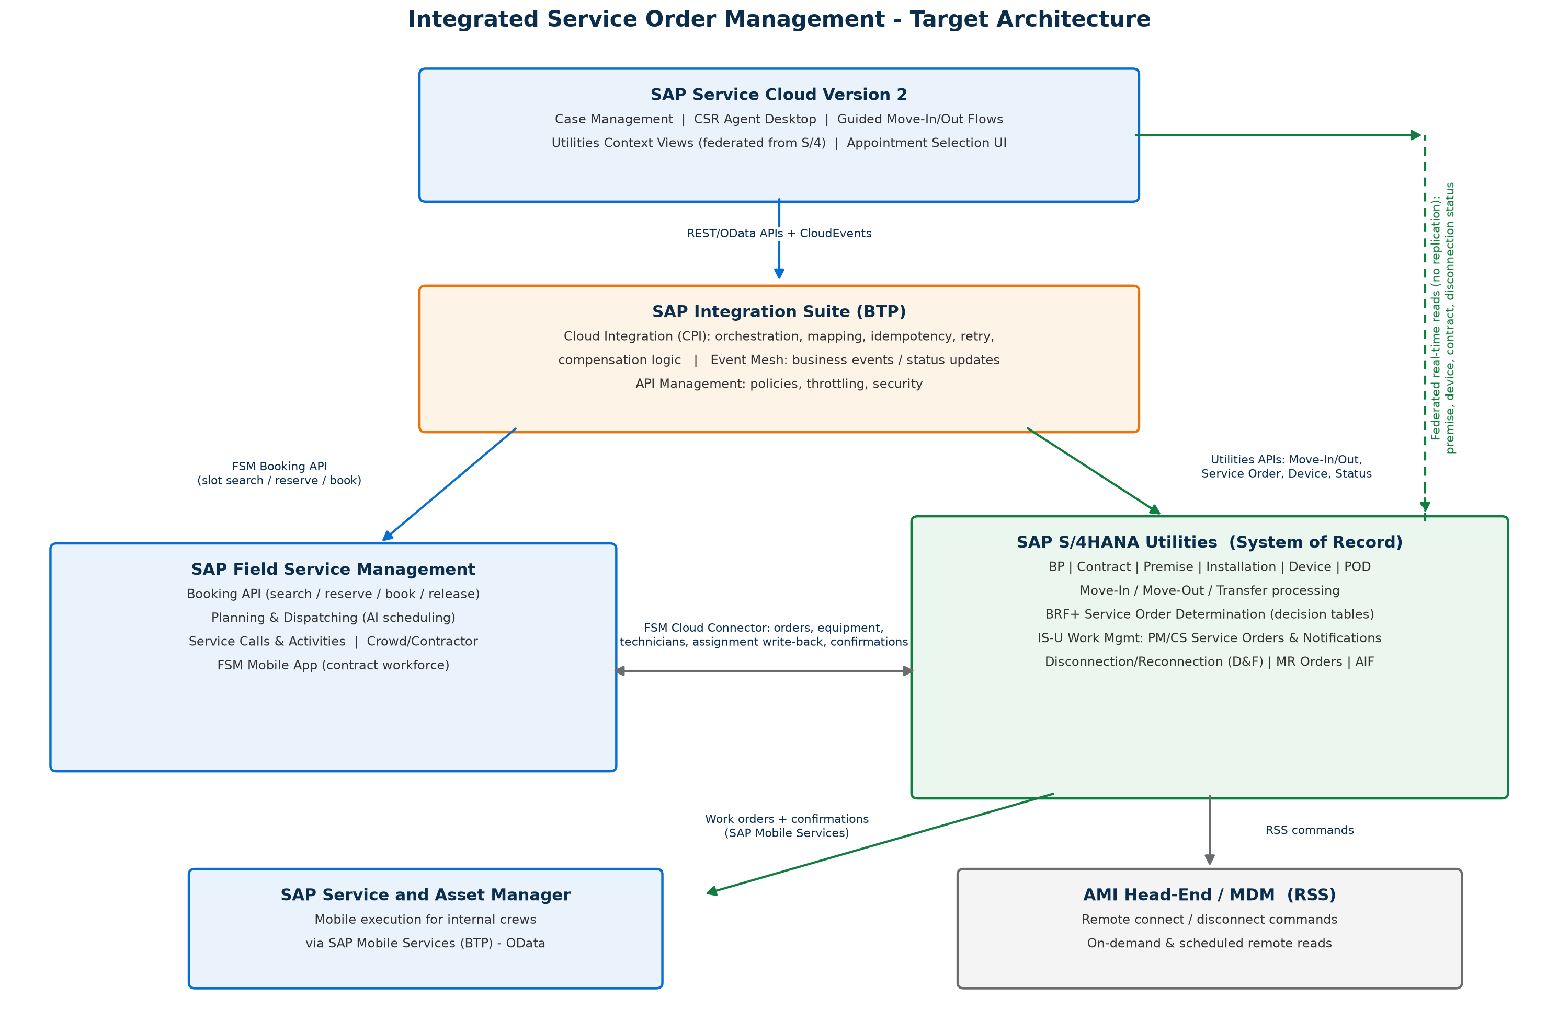
Figure 1 - Target architecture and integration touchpoints

Guiding principles:
- One system of record per object. S/4HANA Utilities owns all utilities master data and the service order; FSM owns the schedule; SCV2 owns the customer interaction (case). No object is mastered in two places.
- One scheduling engine. FSM is the single planning and dispatching engine for appointment-relevant work. For internal crews using SSAM, FSM writes the assignment (personnel number, scheduled start/end) back to the S/4 order operation via the FSM Cloud Connector; SSAM downloads the order through SAP Mobile Services. Contractors execute in FSM Mobile. MRS must not schedule the same order types (see open question OQ-2).
- Federate, do not replicate, technical master data into SCV2. Premise, installation, device, contract and disconnection status are read from S/4 in real time via the SCV2 utilities integration.
- Rules live where the data lives. Service order determination runs as BRF+ decision tables inside S/4HANA Utilities, invoked synchronously during move-in/out processing and by the daily RSS batch.
- Design for AMI first. Every field-order rule has a remote-command (RSS) branch; field orders are the fallback for non-AMI meters, safety-message rejection, and AMI opt-out customers.

System Responsibilities and System of Record
Object / Capability | System of Record | Consumers / Copies
Business Partner, Contract, Contract Account | S/4HANA Utilities | SCV2 (replicated BP for interaction context)
Premise, Connection Object, Installation, Device, POD | S/4HANA Utilities | SCV2 (federated read); FSM (equipment + service address replica for routing)
Case / Interaction / Ticket | Service Cloud V2 | S/4 (reference ID only)
Service Order (PM/CS order + IS-U service notification) | S/4HANA Utilities | FSM (Service Call + Activity); SSAM (order download)
Appointment / Schedule / Assignment | FSM | S/4 (assignment write-back on order operation); SCV2 (confirmed slot on case)
Disconnection Document, Meter Reading Order | S/4HANA Utilities | -
RSS command and result | S/4HANA Utilities (trigger) / AMI Head-End (execution) | SCV2 (status on case)
Time confirmations, materials, meter data from field | S/4HANA Utilities (posted from FSM/SSAM) | SCV2 (status events)

Scenario 1 - Service Order Creation with Real-Time Appointment Booking

Process Flow
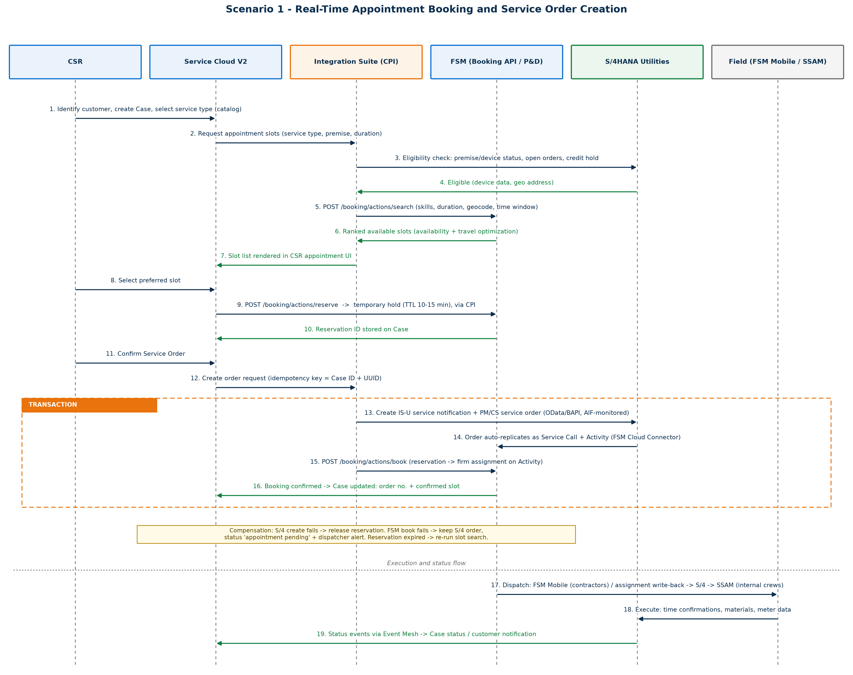
Figure 2 - Sequence: slot search, reservation, order creation and booking confirmation

Step | Actor / System | Description
1 | CSR in SCV2 | Identify customer; utilities context (contract, premise, device, disconnection status, open orders) is displayed via federated reads from S/4. CSR creates a case and selects a service type from the service catalog.
2-4 | CPI + S/4 | CPI enriches the slot request: maps service type to order code, skill profile and standard duration; performs eligibility checks in S/4 (premise status, duplicate open orders, credit hold).
5-7 | FSM Booking API | POST /booking/actions/search with skills, duration, geocoded address and time window. FSM returns ranked slots (technician availability, skills, travel optimization, capacity policies). Slots render in the CSR UI. Target end-to-end latency < 3 seconds.
8-10 | CSR + FSM | CSR selects a slot; POST /booking/actions/reserve places a temporary hold (TTL 10-15 minutes). Reservation ID is stored on the SCV2 case.
11-16 | CPI transaction | On CSR confirmation: (a) create IS-U service notification + PM/CS service order in S/4 (appointment window on order dates); (b) order auto-replicates to FSM as Service Call + Activity via FSM Cloud Connector; (c) POST /booking/actions/book converts the hold into a firm assignment on the Activity; (d) case updated with order number and confirmed slot.
17-19 | Field + status flow | Dispatch to FSM Mobile (contractors) or, via assignment write-back to the S/4 order operation, to SSAM (internal crews). Execution posts confirmations, materials and meter data to S/4. Status events flow through Event Mesh to update the SCV2 case and notify the customer.

APIs and Integration Patterns
Integration | Mechanism / API | Pattern
SCV2 utilities context | SCV2 utilities integration - federated OData reads to S/4 (premise, device, contract, status) | Synchronous read, no replication
Slot search / reserve / book / release | FSM Booking API: /booking/actions/search, /reserve, /book, /release | Synchronous REST via CPI
Eligibility check | S/4 OData (utilities device, contract, disconnection status) or custom gateway service | Synchronous read
Service order creation | S/4 Maintenance/Service Order OData API or BAPI_ALM_ORDER_MAINTAIN / IS-U work management wrapper; AIF-monitored | Synchronous create with idempotency key
S/4 <-> FSM sync (orders, equipment, technicians, assignments, confirmations) | FSM Cloud Connector (standard) | Near-real-time replication
Status to SCV2 | S/4 business events + FSM webhooks -> Event Mesh -> SCV2 Case API | Asynchronous events (CloudEvents)
SSAM | SAP Mobile Add-On / SAP Mobile Services OData; orders selected by work center / personnel assignment | Mobile sync (delta)

Exception Handling and Consistency
Failure | Handling
Reservation TTL expires before CSR confirms | FSM book call fails; CPI re-runs slot search; CSR is prompted with fresh slots. Never silently rebook a different time.
S/4 order creation fails after reserve | CPI compensation: release the FSM reservation immediately; return actionable error to CSR.
FSM book fails after S/4 order created | Do NOT roll back the S/4 order (it is the SoR). Order remains with user status 'Appointment Pending'; dispatcher alert raised in FSM; case shows 'appointment to be confirmed'.
Duplicate submission / CSR retry after timeout | Idempotency key (SCV2 case ID + request UUID) carried end-to-end; CPI de-duplicates.
FSM unavailable | Graceful degradation: order can be created without a slot ('dispatch to schedule'); dispatcher books manually later.
Interface monitoring | AIF in S/4 for inbound order interfaces; CPI message monitoring with alerting into SAP Cloud ALM; FSM connector monitor for replication errors.

Scenario 2 - Move-In / Move-Out / Transfer with Automatic Service Order Determination

Process Flow
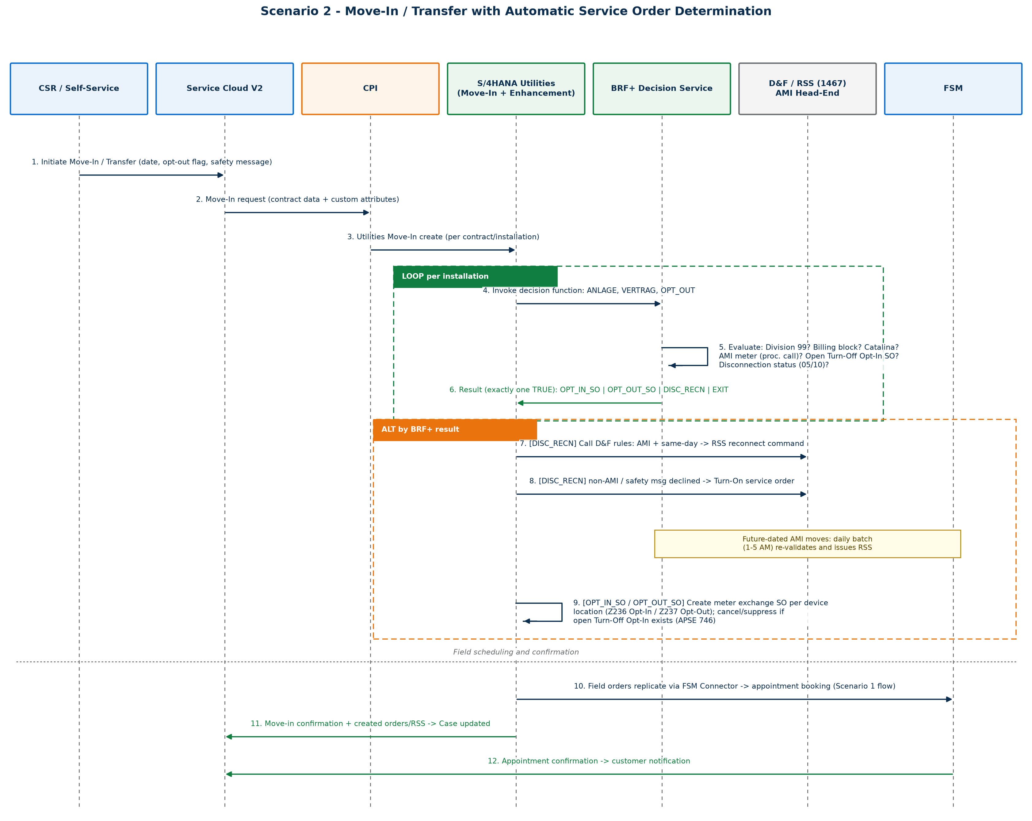
Figure 3 - Sequence: move-in with BRF+ determination (transfer = move-out at old premise + move-in at new premise)

The move-in, move-out and transfer flows share one determination pattern. A transfer is processed in S/4 as a move-out plus a move-in. The enhancement is triggered on submission of the move document and evaluates the BRF+ decision function once per installation (a premise can carry multiple installations - electric, gas, water - and one service order is created per device location).
Step | Description
1 | CSR (or self-service) initiates move-in / move-out / transfer in SCV2, capturing requested date, AMI opt-out request, safety-message acceptance and meter-removal request (move-out).
2 | CPI calls the S/4HANA Utilities move-in / move-out API. Custom attributes (opt-out flag, safety message) travel in the payload.
3 | The S/4 enhancement on move document creation invokes the BRF+ decision function per installation (Section 6).
4 | Exactly one BRF+ output is TRUE: OPT_IN_SO, OPT_OUT_SO, MTR_REMOVAL, DISC_RECN or EXIT.
5 | DISC_RECN: the D&F rules engine (enhancement 1467) determines the concrete outcome - AMI meter and same-day/backdated move: RSS remote command; non-AMI meter or safety message declined: Turn-On/Turn-Off field service order; future-dated AMI move: deferred to the daily batch (runs 01:00-05:00, move-out mode before move-in mode) which re-validates and issues the RSS on the effective date.
6 | OPT_IN_SO / OPT_OUT_SO / MTR_REMOVAL: the enhancement creates the meter exchange or removal order per unique device location, including the in-flight-order suppression/cancellation logic of APSE Decision 746.
7 | Any created field order replicates to FSM and enters the Scenario 1 appointment flow (customer-facing appointment where applicable); order requested date defaults to the move date, or system date for backdated moves (APSE Decision 659).
8 | Move confirmation, created orders/RSS references and appointment details update the SCV2 case; customer is notified.

Proposed Order Type Mapping (business view)
Business Situation | Proposed Outcome
Move-in at energized premise, AMI meter, customer accepts AMI | No field order - remote (on-demand) move-in read via AMI
Move-in at disconnected premise, AMI meter with RSS capability | RSS remote reconnect (same-day) or daily batch (future-dated)
Move-in at disconnected premise, non-AMI meter (incl. Catalina) or safety message declined | Service Turn-On field order
Move-in, customer opts out of AMI, AMI meter installed | Meter Exchange (Turn-On Opt-Out): AMI -> mechanical
Move-in, prior customer was opt-out (mechanical meter), new customer accepts AMI | Meter Exchange (Turn-On Opt-In): mechanical -> AMI
Move-out, no successor, AMI meter | RSS remote disconnect (same-day) or daily batch; final read remote
Move-out, no successor, non-AMI meter | Service Turn-Off field order + move-out read
Move-out with next-day move-in (back-to-back) | No disconnection - service remains on; move-out read only
Move-out of an AMI opt-out customer | Meter Exchange (Turn-Off Opt-In): mechanical -> AMI on exit
Move-out, customer requests meter removal | Meter Removal order (+ turn-off)
Any move for installation division 99 (Added Facility) | No order

Note: meter reading orders for move-in/move-out reads (reading reasons 06 / 03) are generated by standard IS-U move processing and are not part of the custom determination.

BRF+ Decision Service Design
BRF+ application Z_CS_MOVE_SO_DET with four decision functions sharing one result structure. The online functions are invoked by the move-in / move-out enhancements; the batch functions are invoked by the daily RSS program. Exactly one result flag returns TRUE per evaluation. Rules are evaluated top-down; the first matching row wins ('*' = any value).

Functions, Signatures and Result Structure
Function | Trigger | Input Parameters | Output
FN_MOVE_IN_VALIDATION | Enhancement on move-in / transfer-in creation (per installation) | ANLAGE (EANL-ANLAGE), VERTRAG (EVER-VERTRAG), OPT_OUT (Boolean, from SCV2 payload per FS 1090) | OPT_IN_SO, OPT_OUT_SO, DISC_RECN, EXIT (Boolean; exactly one TRUE)
FN_MOVE_OUT_VALIDATION | Enhancement on move-out / transfer-out creation (per installation) | ANLAGE, VERTRAG, MTR_REM_REQ (Boolean, from CREATE_SERVICE = 'X' in move-out payload) | OPT_IN_SO, OPT_OUT_SO, MTR_REMOVAL, DISC_RECN, EXIT (Boolean; exactly one TRUE)
FN_BATCH_MOVE_OUT | Daily batch (01:00-05:00), runs FIRST; per move-out document due on run date (EAUSV, excluding STORAUSZ = 'X') | AUSZBELEG, ANLAGE, VERTRAG, AUSZDAT, VSTELLE | RSS (Boolean), MESSAGE (CHAR40 application-log text)
FN_BATCH_MOVE_IN | Daily batch, runs AFTER move-out mode; per move-in document due on run date (EEINV, excluding reversed) | EINZBELEG, ANLAGE, VERTRAG, EINZDAT, VSTELLE | RSS (Boolean), MESSAGE (CHAR40 application-log text)

Condition Derivations (BRF+ expressions and procedure calls)
Condition | Derivation | Source
DIV_99 | Installation division = '99' (Added Facility) - no turn-on/off ever required | EANL / installation attributes
BILLING_BLOCK | EVER-ABRSPERR <> SPACE on the move-in contract (set by Same-Party / Fuse-Up Inspection logic before this enhancement runs). Agent creates the order manually after block removal. | EVER
OPT_OUT_REQ | Customer requested AMI opt-out during move-in; custom attribute passed from SCV2 (FS 1090) | Move-in payload
MTR_REM_REQ | Customer requested turn-off with meter removal; CREATE_SERVICE = 'X' in move-out payload | Move-out payload
AMI_METER | Custom function module invoked via BRF+ procedure call: installed device is AMI with remote disconnect/reconnect (RSS) capability | Device / register data (EASTL, EGERH)
OPEN_TOFF_OPTIN | Open Turn-Off Opt-In order exists: CL_COD_UTIL_SRV_ORD_HELP=>GET_SERVICE_ORDERS, type TOFF, status '10'/'20', with AFIH-ILART = '233' | PM order data (AFIH)
NEXT_DAY_MOVE_IN | EVER entry exists with move-in date = move-out date + 1 for the same ANLAGE and LOEVM = SPACE (not cancelled) | EVER
OWNER_ALLOC | Active owner allocation agreement exists for the premise (service reverts to owner - no disconnection) | EPROP
DISC_STATUS | ISU_INSTLN_STATUS_DETERMINE (X_ANLAGE, X_KEYDATE) -> Y_EANLDISCST: '05'/'10' = disconnected; '00'/'15' = energized | Disconnection document status
OPEN_FIELD_SO | Open turn-on / turn-off / meter replacement or removal order already exists for the installation (custom method per W-CIM-CS-02 Align New Move-In Date with Service Order) | PM orders

Decision Table DT_MOVE_IN (online - move-in and transfer-in)
R# | DIV_99 | BILLING_BLOCK | CATALINA | OPT_OUT_REQ | AMI_METER | OPEN_TOFF_OPTIN | Result | Action by Enhancement
1 | Y | * | * | * | * | * | EXIT | No order (Added Facility).
2 | N | Y | * | * | * | * | EXIT | No order; agent creates order/RSS manually after billing block is resolved.
3 | N | N | Y | * | * | * | DISC_RECN | Call D&F rules (1467) with Activity = Move-In; mechanical meters only -> Turn-On field order if installation is disconnected (status 05/10).
4 | N | N | N | Y | * | Y | EXIT | APSE 746: cancel the in-flight Turn-Off Opt-In order (action code '03') and suppress the new opt-out order - the mechanical meter stays in place.
5 | N | N | N | Y | Y | N | OPT_OUT_SO | Create Turn-On Opt-Out meter exchange (order code Z237), one per unique device location; exchanges AMI -> mechanical.
6 | N | N | N | N | Y | * | DISC_RECN | Call D&F rules (1467): same-day/backdated -> RSS reconnect if disconnected; future-dated -> daily batch issues RSS on effective date; safety message declined -> Turn-On field order instead.
7 | N | N | N | N | N | Y | EXIT | APSE 746: in-flight Turn-Off Opt-In will install the AMI meter; turn-on is handled by the AMI process - do not create a second order.
8 | N | N | N | N | N | N | OPT_IN_SO | Prior customer was opt-out: create Turn-On Opt-In meter exchange (order code Z236, reference object = premise); exchanges mechanical -> AMI.

Decision Table DT_MOVE_OUT (online - move-out and transfer-out)
R# | DIV_99 | MTR_REM_REQ | CATALINA | NEXT_DAY_MOVE_IN | AMI_METER | Result | Action by Enhancement
1 | Y | * | * | * | * | EXIT | No order (Added Facility).
2 | N | Y | * | * | * | MTR_REMOVAL | Create Meter Removal order (order code Z214, reference object = equipment); turn-off accompanies removal via D&F rules.
3 | N | N | Y | * | * | DISC_RECN | Call D&F rules (1467) with Activity = Move-Out; Turn-Off field order (Catalina is always mechanical).
4 | N | N | N | Y | * | EXIT | Back-to-back occupancy: no disconnection, service remains on.
5 | N | N | N | N | N | OPT_IN_SO | Departing customer was AMI opt-out: create Turn-Off Opt-In meter exchange (order code Z233), one per unique device location; exchanges mechanical -> AMI on exit.
6 | N | N | N | N | Y | DISC_RECN | Call D&F rules (1467): same-day/backdated -> RSS disconnect; future-dated -> daily batch issues RSS on the move-out date.

Decision Table DT_BATCH_MOVE_OUT (daily batch - RSS disconnections)
Seq | Check (stop at first hit) | If TRUE -> RSS / MESSAGE | If FALSE
0 | Move-out document reversed (EAUSV-STORAUSZ = 'X') | Skip document (not selected) | Continue
1 | NEXT_DAY_MOVE_IN exists | RSS = FALSE; log 'Next Day Move-In for <doc#>' | Continue
2 | OWNER_ALLOC - active owner allocation agreement (EPROP) | RSS = FALSE; log 'Owner Allocation <doc#>' | Continue
3 | OPEN_FIELD_SO - open turn-off / meter replacement or removal order exists | RSS = FALSE; log 'Open Service Orders for <doc#>' | Continue
4 | DISC_STATUS in ('05','10') - already disconnected | RSS = FALSE; log 'Installation disconnected for <doc#>' | Continue
5 | All checks passed | RSS = TRUE -> call D&F rules (1467, Activity = Move-Out) to issue the RSS disconnect; log 'Disconnection RSS generated for <doc#>' | -

Decision Table DT_BATCH_MOVE_IN (daily batch - RSS reconnections)
Seq | Check (stop at first hit) | If TRUE -> RSS / MESSAGE | If FALSE
0 | Move-in document reversed | Skip document (not selected) | Continue
1 | BILLING_BLOCK (EVER-ABRSPERR <> SPACE) | RSS = FALSE; log 'Billing Block <doc#>' | Continue
2 | DISC_STATUS not in ('05','10') - already energized | RSS = FALSE; log 'Reconnection not needed for <doc#>' | Continue
3 | OPEN_FIELD_SO - open turn-on / meter replacement order exists (non-RSS meter, opt-out replacement, or safety message declined) | RSS = FALSE; log 'Open Service Orders for <doc#>' | Continue
4 | All checks passed | RSS = TRUE -> call D&F rules (1467, Activity = Move-In) to issue the RSS reconnect; log 'Reconnection RSS generated for <doc#>' | -

Service Order Codes and Creation Parameters
Order Code | Order | Trigger | Reference Object | Notes
Z214 | Meter Removal | Move-out with CREATE_SERVICE = 'X' | Equipment (object type '02') | Customer-requested turn-off with meter removal
Z233 | Turn-Off Opt-In (meter exchange) | Move-out of an opt-out customer | Equipment (object type '02') | Exchange mechanical -> AMI on exit; ILART '233' is the in-flight-order marker checked by DT_MOVE_IN
Z236 | Turn-On Opt-In (meter exchange) | Move-in where prior customer was opt-out | Premise (object type '01') | Exchange mechanical -> AMI
Z237 | Turn-On Opt-Out (meter exchange) | Move-in where customer opts out of AMI | Equipment (object type '02') | Exchange AMI -> mechanical
TUON / TOFF | Standard Turn-On / Turn-Off | DISC_RECN result via D&F rules (1467) | Installation / device location | 1467 owns order-vs-RSS determination, safety-message handling and disconnection-document integration

- Creation FM (C4C-era): ISU_C4C_SRV_ORD_CREATE with IV_ACTIONCODE '01' (create) / '03' (cancel); start date = requested move date, or system date if the move is backdated (APSE Decision 659); the agent may adjust afterwards.
- Device-location resolution: installation -> EASTL (LOGIKNR, open-ended) -> EGERH (EQUNR, KOMBINAT = 'Z'); de-duplicate by device location so exactly one order is created per device location; a premise with electric, gas and water installations therefore yields one order per commodity device location.

Modernization Notes (C4C-era hook points to re-validate for SCV2)
FS 1087 (C4C / MDT) artifact | SCV2 target-state equivalent
Enhancement spot COD_UTILITIES_ERP_CUST_INFO, FM ISU_C4C_MOVE_IN_OUT_TRANS_SRV (move-out); implicit enhancement in ISU_C4C_UTILITIES_MDT_MVI_CRT, process code '0003' (move-in) | Re-anchor the same logic on the S/4 move-in/out APIs used by the SCV2 utilities integration (or CPI-called move-in/out services). The BRF+ functions, decision tables and D&F integration are unchanged - only the trigger point moves.
Custom attributes (opt-out, safety message, inspection) via X_CONTAINER (FS 1090) | Model as extension fields on the SCV2 case / move flow; map through CPI into the S/4 move-in payload.
CL_COD_UTIL_SRV_ORD_HELP=>GET_SERVICE_ORDERS for open-order checks | Verify availability in the target S/4 release; otherwise wrap an equivalent read on PM order data (AUFK/AFIH + object list).
ISU_C4C_SRV_ORD_CREATE for order create/cancel | Verify in target release; alternative is the Maintenance Order API / BAPI_ALM_ORDER_MAINTAIN with IS-U object linkage.
RSS generated via enhancement 1467 (D&F rules) | Retain: D&F/disconnection-document customizing plus AMI head-end integration (MDUS) remains the RSS execution path.

Master Data and Transactional Data Dependencies
- Business Partner: mastered in S/4; replicated bidirectionally to SCV2 via CPI standard content; identity key mapping held on both sides.
- Technical master data: connection object, premise, installation, device, POD remain in S/4; federated into SCV2; equipment and service addresses replicated to FSM. Service addresses must geocode cleanly - slot search quality depends on it.
- FSM foundation data: plants, work centers, technicians (HR mini-master), skills/tags, activity types synchronized from S/4 via the FSM Cloud Connector.
- Service catalog alignment: three-way governed mapping - SCV2 service type <-> S/4 order code/order type (incl. Z214, Z233, Z236, Z237, TUON, TOFF) <-> FSM skill + duration profile. Assign an owner for this mapping.
- Disconnection documents: D&F customizing (activities, order/notification generation) underpins enhancement 1467 and the RSS path; status values 05/10 (disconnected) and 00/15 (energized) drive the decision tables.
- Meter reading orders: standard move-in/out reads (reading reasons 06 / 03); no custom determination.
- SSAM configuration: mobile status profiles, user-to-work-center assignment aligned to the same order types; assignment write-back from FSM populates operation dates and personnel.
- Custom transactional attributes: opt-out flag, safety-message acceptance, meter-removal request captured in SCV2 and passed through CPI to S/4 (successor of FS 1090).

Assumptions and Open Questions

Assumptions
- S/4HANA Utilities is the system of record for all utilities master data and the service order; FSM is the only scheduling engine for appointment-relevant order types.
- The FS 1087 business rules (AMI/RSS, opt-in/opt-out, Catalina, Division 99, billing block, next-day move-in, owner allocation) remain valid for the target state and were adopted unchanged into the BRF+ design.
- One service order per device location; multi-installation premises produce one order per commodity device location.
- Order requested date = move date; backdated moves are issued for system date (APSE Decision 659).
- The daily RSS batch window is 01:00-05:00 with move-out mode completing before move-in mode.
- AMI opt-out fees and BPEM case creation remain manual (per FS 1087 assumption).

Open Questions for the Client
# | Question | Impact
OQ-1 | Workforce split: which order types go to internal crews (SSAM) vs. contractors (FSM Mobile)? | Dispatch design, mobile rollout scope
OQ-2 | Is MRS in scope today, and is it being retired in favor of FSM as the single scheduler? | Scheduling architecture; double-booking risk
OQ-3 | AMI penetration and RSS capability per commodity / territory; which MDM / head-end system and command interface? | How often rules short-circuit field work
OQ-4 | Leave-on vs. turn-off policy at move-out; regulatory moratoria; owner-allocation agreements coverage | DT_MOVE_OUT and batch rules
OQ-5 | Same-day / emergency appointments: within FSM Booking API capacity policies or a dispatcher exception queue? | Scenario 1 design
OQ-6 | Will self-service (portal / commerce) reuse the same CPI orchestration and BRF+ determination? | Strongly recommended - one determination service, many channels
OQ-7 | Target S/4 deployment and release level - availability of standard utilities move-in/out APIs vs. BAPI wrappers; validity of C4C-era FMs listed in Section 6.9 | Interface build effort
OQ-8 | Deposit / credit check during move-in - does it gate order creation? | Move-in orchestration
OQ-9 | Gas relight / safety-check policy: does any gas turn-on always require a field visit regardless of AMI? | Additional rule dimension (utility type)
OQ-10 | Reservation TTL and slot search policies (AM/PM windows, capacity reserve for emergencies)? | FSM booking configuration

Implementation Roadmap
Phase | Indicative Duration | Scope
0 - Foundation | 6-8 weeks | BTP setup (Integration Suite, Event Mesh, Mobile Services); BP replication SCV2 <-> S/4; SCV2 utilities federation; FSM Cloud Connector + foundation data (work centers, technicians, skills); geocoding validation of service addresses.
1 - Scenario 1 | 10-12 weeks | Service catalog three-way mapping; CPI booking orchestration (search/reserve/book with compensation); order creation flow with AIF monitoring; status events to SCV2; dispatcher exception processes; latency/volume testing of slot search.
2 - Scenario 2 | 10-12 weeks | BRF+ application ZCIM_MOVE_SO_DET (4 decision functions); move-in/out enhancements on the SCV2-era hook points; D&F customizing + 1467-equivalent rules; daily RSS batch with application logging; AMI head-end command integration; SOX control evidence (automated preventative control per FS 1087 Section 3.4).
3 - Mobile execution | parallel to 1-2 | SSAM configuration + assignment write-back pattern; FSM Mobile rollout for contractors; meter data capture to IS-U.
4 - Hardening & rollout | 6 weeks | Failover / degradation drills (FSM down, reservation expiry, book-after-create failure); regression of move-in/out volumes (~1.2M turn-ons and ~1.1M turn-offs per year per FS 1087); hypercare.

Key Design Considerations for SAP Utilities
- Slot-search latency is the CSR experience. Keep the synchronous path SCV2 -> CPI -> FSM only; run S/4 eligibility checks in parallel; cache the service-type-to-skill mapping in CPI. Target < 3 s end to end.
- Reserve before create, book after create. Never firm-book a schedule before the order exists in the system of record; never roll back the S/4 order to fix a scheduling failure - reconcile the schedule instead.
- Every field-order rule needs a remote branch. The AMI/RSS short-circuit (rules DT_MOVE_IN R6, DT_MOVE_OUT R6 and both batch tables) is where the business case lives: each avoided truck roll is direct cost saving.
- Regulatory clock-times. Reconnect-after-payment SLAs must map to FSM priorities -> due dates -> scheduling policies.
- Batch and online must be idempotent against each other. The open-order checks (OPEN_FIELD_SO) in both batch tables exist precisely to prevent the batch from duplicating what the online enhancement already created - preserve them.
- Interface observability is a deliverable. AIF in S/4, CPI monitoring, FSM connector monitor and the ZCIM application logs (ZMVO_BATCH / ZMVI_BATCH) feed SAP Cloud ALM alerting from day one.
- SOX: the determination is a preventative automated control (incorrect switching / metering leads to incorrect usage data); keep the decision tables under transport + change control with business sign-off on every rule change.

Appendix A - References and Traceability
Reference | Relevance
FS 1087 E-CIM-CS-02 Create Work Order During Move-In/Move-Out/Transfer v0.6 (10/2018) | Source of all Scenario 2 determination rules, order codes, batch design, volumes and unit test scenarios
FS 1467 E-DF-WM-03 Disconnection and Reconnection Document Order/Rules | Owns turn-on/off order-vs-RSS determination, safety-message handling; called by every DISC_RECN outcome
FS 1090 E-CIM-CS-02 Capture Opt-Out, Inspection Required and Service Fees | Source of the OPT_OUT and safety-message attributes in the move-in payload
W-CIM-CS-02 Align New Move-In Date with Service Order | Custom open-order lookup used by the batch checks
APSE Decision 659 - Service Order Dates | Backdated moves issue orders for system date
APSE Decision 746 - Move-In/Out Service Orders | In-flight Turn-Off Opt-In suppression / cancellation logic (DT_MOVE_IN rules 4 and 7)
Linked requirements 586, 1225, 3462-3465 | Turn-on after force-off; AMI exchange on opt-out contract closure; opt-in/opt-out meter exchange routing

Requirement-to-rule traceability:
Requirement | Design Element
586 - turn-on when service was forced off | DT_MOVE_IN R3/R6 via D&F rules (1467); DT_BATCH_MOVE_IN seq 2/4
1225 - install smart meter when opt-out contract ends | DT_MOVE_OUT R5 (Z233 Turn-Off Opt-In)
3465 - meter exchange on AMI opt-out request | DT_MOVE_IN R5 (Z237 Turn-On Opt-Out)
3464 - AMI installation on opt-out customer move-out | DT_MOVE_OUT R5 (Z233)
3463 - AMI installation when new customer opts in after opt-out predecessor | DT_MOVE_IN R8 (Z236 Turn-On Opt-In)
3462 - non-AMI installation when move-in customer opts out | DT_MOVE_IN R5 (Z237)

